**Load balancer:**

1. **Launch 2-instances.&Host a website on each .**

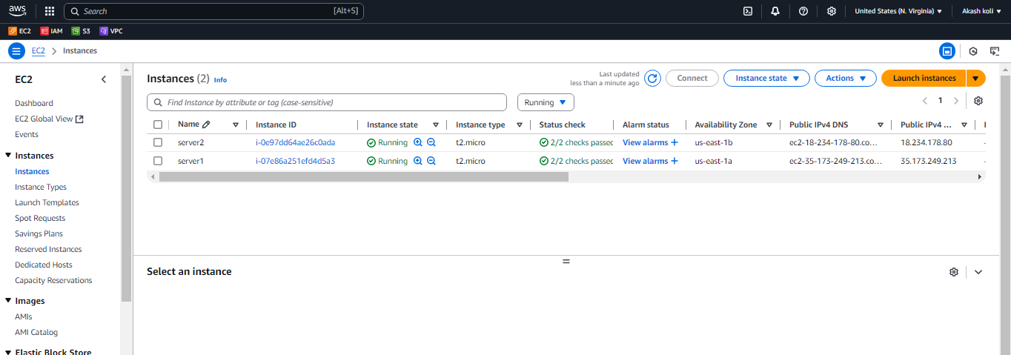

**Server1:**

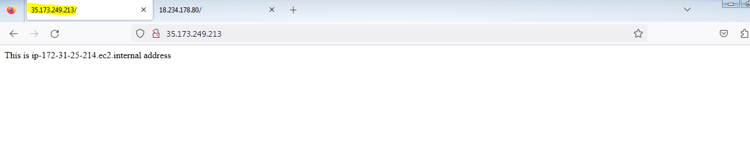

**Server2:**

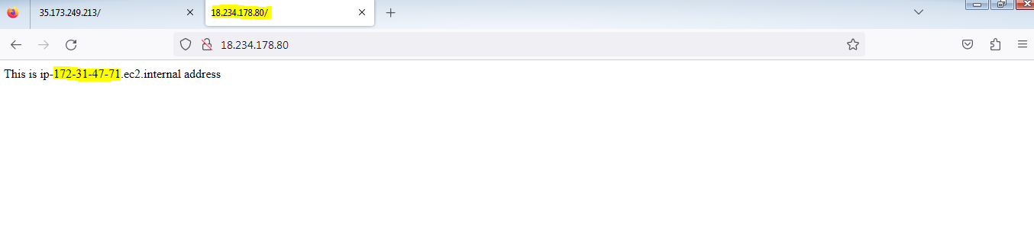

**2. Create Load balancer:**

**a.**create security group-allow http-80

**b. Create Target group:**

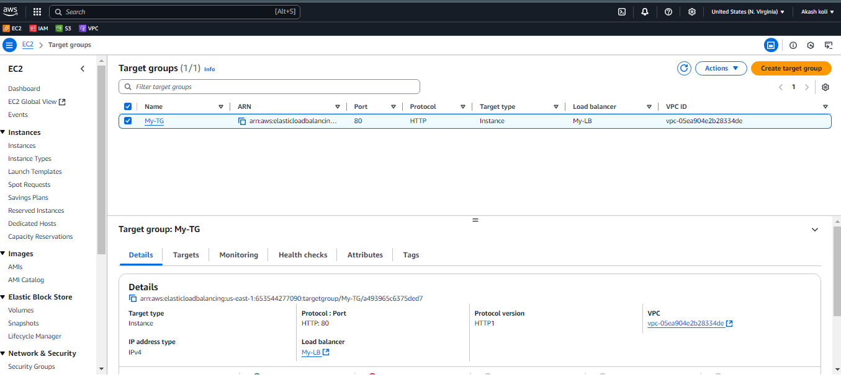

**LB:**

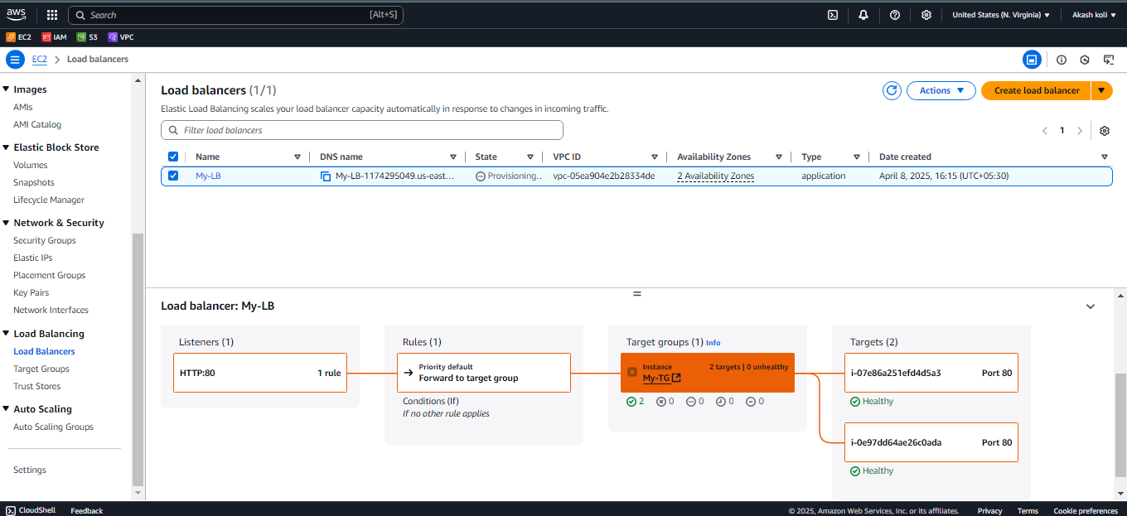

**Out;-**

1. **Check load balancer DNS : routing traffic to both instance while refreshing.**

